Operational Database

🌟 Definition
# Source: AI Source: Provided by: [Data Path: Persons Table -> ID Column: 1, Name_En Column: Motasem Essam] -> From: [ChatGPT] on [6/10/2026]
An Operational Database is a database designed to store, manage, and process the day-to-day operations of an organization in real time.
It is optimized for transaction processing, meaning it handles frequent inserts, updates, and deletes efficiently.
Operational databases are also called:
- OLTP Databases (Online Transaction Processing)
- Transactional Databases
- Production Databases

🎯 Purpose
# Source: AI Source: Provided by: [Data Path: Persons Table -> ID Column: 1, Name_En Column: Motasem Essam] -> From: [ChatGPT] on [6/10/2026]
Operational databases are used to:
- Process daily transactions
- Store current data
- Support business applications
- Serve users in real time
- Handle CRUD operations (Create, Read, Update, Delete)

🧠 Simple Example
# Source: AI Source: Provided by: [Data Path: Persons Table -> ID Column: 1, Name_En Column: Motasem Essam] -> From: [ChatGPT] on [6/10/2026]
An online store needs to:
- Create orders
- Update inventory
- Process payments
- Manage customers
These activities happen continuously throughout the day.
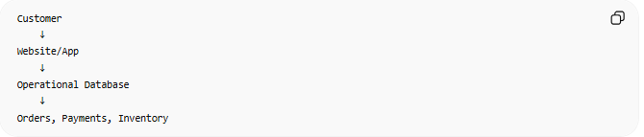
Customer
↓
Website/App
↓
Operational Database
↓
Orders, Payments, Inventory

🔢 Main Characteristics

1. ⚡ Real-Time Operations
# Source: AI Source: Provided by: [Data Path: Persons Table -> ID Column: 1, Name_En Column: Motasem Essam] -> From: [ChatGPT] on [6/10/2026]
Data changes constantly.
Examples:
- New order placed
- User logs in
- Product stock updated

2. 🔄 Frequent Transactions
# Source: AI Source: Provided by: [Data Path: Persons Table -> ID Column: 1, Name_En Column: Motasem Essam] -> From: [ChatGPT] on [6/10/2026]
Operational databases perform many:
- INSERT
- UPDATE
- DELETE
- SELECT
queries every second.

3. 📅 Current Data
# Source: AI Source: Provided by: [Data Path: Persons Table -> ID Column: 1, Name_En Column: Motasem Essam] -> From: [ChatGPT] on [6/10/2026]
Usually stores the latest version of information.
Example:

Current account balance
Current inventory quantity
Current customer address

4. 👥 Supports Many Users
# Source: AI Source: Provided by: [Data Path: Persons Table -> ID Column: 1, Name_En Column: Motasem Essam] -> From: [ChatGPT] on [6/10/2026]
Thousands or millions of users may access the database simultaneously.

5. 🔐 Transaction Support
# Source: AI Source: Provided by: [Data Path: Persons Table -> ID Column: 1, Name_En Column: Motasem Essam] -> From: [ChatGPT] on [6/10/2026]
Uses database transactions to ensure:
- Accuracy
- Consistency
- Reliability
Through the ACID properties.

📚 Example Tables
# Source: AI Source: Provided by: [Data Path: Persons Table -> ID Column: 1, Name_En Column: Motasem Essam] -> From: [ChatGPT] on [6/10/2026]
Customers
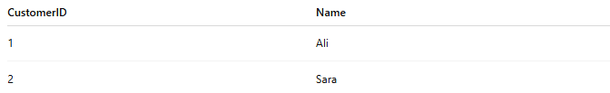
CustomerID | Name
1 | Ali
2 | Sara

Orders
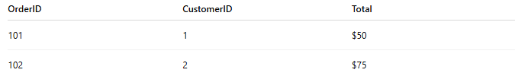
OrderID | CustomerID | Total
101 | 1 | $50
102 | 2 | $75

Products
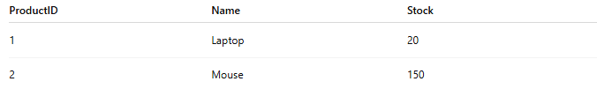
ProductID | Name | Stock
1 | Laptop | 20
2 | Mouse | 150

🏦 Real-World Uses
# Source: AI Source: Provided by: [Data Path: Persons Table -> ID Column: 1, Name_En Column: Motasem Essam] -> From: [ChatGPT] on [6/10/2026]
Banking Systems
- Deposits
- Withdrawals
- Transfers
E-Commerce
- Orders
- Payments
- Inventory updates
Hospital Systems
- Patient records
- Appointments
- Billing
Airline Systems
- Reservations
- Ticket purchases
- Seat assignments
Social Media
- Posts
- Likes
- Comments
- Messages

🌍 Popular Operational Databases
# Source: AI Source: Provided by: [Data Path: Persons Table -> ID Column: 1, Name_En Column: Motasem Essam] -> From: [ChatGPT] on [6/10/2026]
Relational Databases
- MySQL
- PostgreSQL
- Microsoft SQL Server
- Oracle Database
NoSQL Databases
- MongoDB
- Cassandra

⚖️ Operational Database vs Data Warehouse
# Source: AI Source: Provided by: [Data Path: Persons Table -> ID Column: 1, Name_En Column: Motasem Essam] -> From: [ChatGPT] on [6/10/2026]
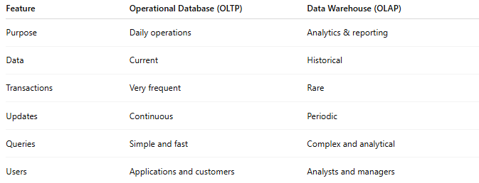
Feature | Operational Database (OLTP) | Data Warehouse (OLAP)
Purpose | Daily operations | Analytics & reporting
Data | Current | Historical
Transactions | Very frequent | Rare
Updates | Continuous | Periodic
Queries | Simple and fast | Complex and analytical
Users | Applications and customers | Analysts and managers

Example
Operational Database
Current inventory = 50 units
Data Warehouse
Inventory trends for the last 5 years

🔗 How an Operational Database Works
# Source: AI Source: Provided by: [Data Path: Persons Table -> ID Column: 1, Name_En Column: Motasem Essam] -> From: [ChatGPT] on [6/10/2026]
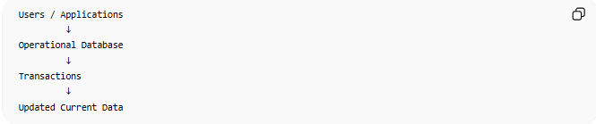
Users / Applications
↓
Operational Database
↓
Transactions
↓
Updated Current Data

🧠 Simple Analogy
# Source: AI Source: Provided by: [Data Path: Persons Table -> ID Column: 1, Name_En Column: Motasem Essam] -> From: [ChatGPT] on [6/10/2026]
Think of:
🏪 Operational Database = a store cashier system
- Handles today's customers
- Records today's sales
- Updates inventory immediately
🏢 Data Warehouse = the company's analysis department
- Studies years of sales history
- Creates reports and forecasts

🧭 Summary
# Source: AI Source: Provided by: [Data Path: Persons Table -> ID Column: 1, Name_En Column: Motasem Essam] -> From: [ChatGPT] on [6/10/2026]
An Operational Database (OLTP Database) is a database designed to support the daily operations of an organization by storing and processing current data through fast, reliable, real-time transactions such as orders, payments, reservations, and account updates.

Data Warehouse

🌟 Definition
# Source: AI Source: Provided by: [Data Path: Persons Table -> ID Column: 1, Name_En Column: Motasem Essam] -> From: [ChatGPT] on [6/10/2026]
A Data Warehouse (DW) is a centralized repository that stores large amounts of historical data collected from multiple sources for reporting, analytics, and business intelligence (BI).
Unlike operational databases, a data warehouse is optimized for analysis, not daily transactions.

🎯 Purpose
# Source: AI Source: Provided by: [Data Path: Persons Table -> ID Column: 1, Name_En Column: Motasem Essam] -> From: [ChatGPT] on [6/10/2026]
A data warehouse helps organizations:
- Analyze historical data
- Generate reports
- Identify trends
- Support decision-making
- Combine data from multiple systems
- Power dashboards and business intelligence tools

🧠 Simple Example
# Source: AI Source: Provided by: [Data Path: Persons Table -> ID Column: 1, Name_En Column: Motasem Essam] -> From: [ChatGPT] on [6/10/2026]
A company has:
- Sales database
- Customer database
- Inventory database
- Website analytics
Instead of analyzing each system separately, data is copied into a Data Warehouse.
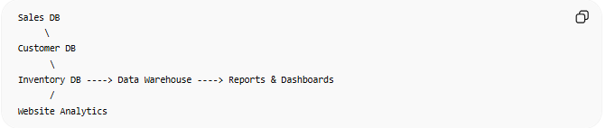
Sales DB
\
Customer DB
\
Inventory DB ----> Data Warehouse ----> Reports & Dashboards
/
Website Analytics

📚 What Data is Stored?
# Source: AI Source: Provided by: [Data Path: Persons Table -> ID Column: 1, Name_En Column: Motasem Essam] -> From: [ChatGPT] on [6/10/2026]
Examples:
- Sales history
- Customer activity
- Product performance
- Financial records
- Marketing campaigns
- Website traffic
Usually data is stored for months or years.

🔢 Main Components of a Data Warehouse

1. 📥 Data Sources
# Source: AI Source: Provided by: [Data Path: Persons Table -> ID Column: 1, Name_En Column: Motasem Essam] -> From: [ChatGPT] on [6/10/2026]
The systems that generate data.
Examples:
- Databases
- ERP systems
- CRM systems
- APIs
- Spreadsheets

2. 🔄 ETL / ELT Process
# Source: AI Source: Provided by: [Data Path: Persons Table -> ID Column: 1, Name_En Column: Motasem Essam] -> From: [ChatGPT] on [6/10/2026]
Moves data into the warehouse.
ETL
Extract → Transform → Load
ELT
Extract → Load → Transform
Purpose:
- Clean data
- Standardize formats
- Combine sources

3. 🏢 Data Warehouse Storage
# Source: AI Source: Provided by: [Data Path: Persons Table -> ID Column: 1, Name_En Column: Motasem Essam] -> From: [ChatGPT] on [6/10/2026]
The central repository where data is stored.
Characteristics:
- Large-scale
- Historical
- Structured
- Optimized for querying

4. 📊 Analytics & Reporting Layer
# Source: AI Source: Provided by: [Data Path: Persons Table -> ID Column: 1, Name_En Column: Motasem Essam] -> From: [ChatGPT] on [6/10/2026]
Used by:
- Analysts
- Managers
- Executives
- BI tools
Examples:
- Reports
- Dashboards
- KPIs

📈 Operational Database vs Data Warehouse
# Source: AI Source: Provided by: [Data Path: Persons Table -> ID Column: 1, Name_En Column: Motasem Essam] -> From: [ChatGPT] on [6/10/2026]
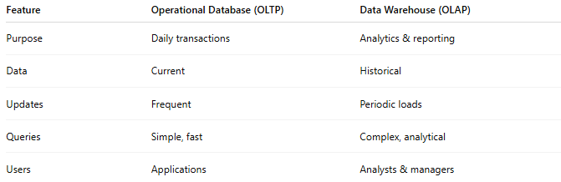
Feature | Operational Database (OLTP) | Data Warehouse (OLAP)
Purpose | Daily transactions | Analytics & reporting
Data | Current | Historical
Updates | Frequent | Periodic loads
Queries | Simple, fast | Complex, analytical
Users | Applications | Analysts & managers

Example
Operational Database
Current customer orders
Data Warehouse
All customer orders from the last 10 years

🏦 Real-World Uses
# Source: AI Source: Provided by: [Data Path: Persons Table -> ID Column: 1, Name_En Column: Motasem Essam] -> From: [ChatGPT] on [6/10/2026]
Retail
- Sales analysis
- Product trends
Banking
- Financial reporting
- Risk analysis
Healthcare
- Patient statistics
- Treatment analysis
E-commerce
- Customer behavior analysis
- Revenue forecasting

🌍 Popular Data Warehouse Platforms
# Source: AI Source: Provided by: [Data Path: Persons Table -> ID Column: 1, Name_En Column: Motasem Essam] -> From: [ChatGPT] on [6/10/2026]
- Snowflake
- Google BigQuery
- Amazon Redshift
- Azure Synapse Analytics

🔗 How a Data Warehouse Works
# Source: AI Source: Provided by: [Data Path: Persons Table -> ID Column: 1, Name_En Column: Motasem Essam] -> From: [ChatGPT] on [6/10/2026]
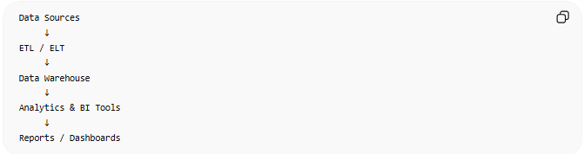
Data Sources
↓
ETL / ELT
↓
Data Warehouse
↓
Analytics & BI Tools
↓
Reports / Dashboards

🧠 Simple Analogy
# Source: AI Source: Provided by: [Data Path: Persons Table -> ID Column: 1, Name_En Column: Motasem Essam] -> From: [ChatGPT] on [6/10/2026]
Think of:
- Operational Database = a store's cash register 🛒
- Data Warehouse = the company's archive and analysis center 🏢📊
The cash register handles today's sales, while the warehouse stores years of sales data for analysis.

🧭 Summary
# Source: AI Source: Provided by: [Data Path: Persons Table -> ID Column: 1, Name_En Column: Motasem Essam] -> From: [ChatGPT] on [6/10/2026]
A Data Warehouse is a centralized system that stores large amounts of historical data from multiple sources and is optimized for reporting, analytics, business intelligence, and decision-making rather than day-to-day transactions.

